OS Preliminary Report

Introduction:
ML- Based KV Cache Size Prediction for Efficient LLM Memory Management
1. Introduction
Large language models (LLMs) such as GPT-3 [1] have revolutionized natural language processing, enabling applications like chatbots, programming assistants, and machine translation. These models are based on the Transformer architecture [2], which generates tokens autoregressively — one at a time — each depending on all previous tokens. Serving these models efficiently at scale has become a critical challenge, as processing a single LLM request can be up to 10 times more expensive than a traditional web search query [3].
At the core of this serving challenge lies the Key-Value (KV) cache — a table of saved intermediate computations (key and value vectors from the attention mechanism) that grows dynamically as the model generates each new token. For a 13B parameter model, a single token's KV cache requires 800KB of GPU memory, meaning one request can consume up to 1.6GB [3]. Since GPU memory is limited, how efficiently this cache is managed directly determines how many requests can be served simultaneously.
2. Literature Survey
Early LLM serving systems such as FasterTransformer [4] stored the KV cache as a single contiguous block of GPU memory, pre-allocated at the maximum possible sequence length. While simple, this approach suffers from three forms of memory waste: reserved slots for future tokens, internal fragmentation from over-provisioning, and external fragmentation from the memory allocator. Profiling results show that only 20–38% of GPU memory is productively used in these systems [3].
Orca [5] improved serving throughput by introducing iteration-level scheduling — processing requests at the granularity of individual token generation steps rather than entire requests. This reduced queuing delays and eliminated padding waste. However, Orca still relied on contiguous KV cache allocation, limiting how many requests could be batched together.
PagedAttention, introduced in vLLM [3], addressed the memory fragmentation problem by borrowing the concept of virtual memory paging from operating systems. Instead of one large contiguous allocation, the KV cache is divided into small fixed-size blocks (default 16 tokens per block) that can be stored anywhere in GPU memory. A block table maps logical blocks to physical locations, similar to a page table in an OS. This achieved near-zero memory waste and improved throughput by 2–4× over prior systems.
Despite these advances, a key limitation remains: vLLM's block allocator is purely reactive — it allocates blocks one at a time as each fills up during generation. The scheduler has no advance knowledge of how much memory a request will eventually need, leading to suboptimal batching decisions, unnecessary preemptions, and wasted GPU memory in partially filled final blocks. 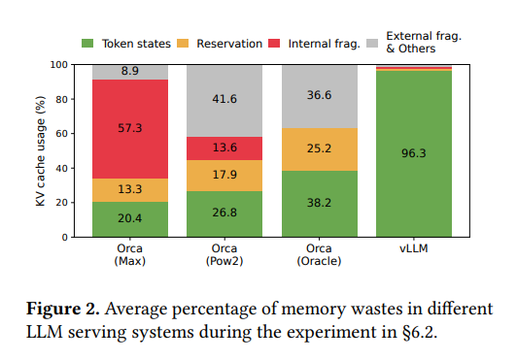

3. Proposed Approach
We propose combining vLLM's memory management with a machine learning based KV cache size predictor. The predictor will estimate the number of KV blocks a request will require before or early in its generation, providing the scheduler with advance memory usage information.
The prediction model will take as input features including input prompt length, task type (chat, code, translation), sampling temperature, maximum token parameter, and early generation growth rate (blocks used per token in the first 10–20 generation steps). We will use quantile regression rather than point estimation, predicting the 85th percentile of expected block usage. This gives a conservative but not wasteful estimate , covering most requests without over-reserving memory.
The predictor integrates with vLLM at two levels. First, at the scheduling level, predictions allow the scheduler to make informed admission decisions — only accepting requests into a batch when predicted total memory fits within available GPU capacity, preventing mid-batch preemptions. Second, at the allocation level, predicted block counts allow pre-warming the block allocator, reducing per-token allocation overhead during generation.
When predictions are wrong, the system gracefully falls back to vLLM's standard dynamic allocation — meaning incorrect predictions degrade performance slightly but never cause correctness issues.
4. Potential Problems
The paper does mention why this method is tricky. The output lengths are fundamentally unpredictable since they depend on both input and the model’s generative behavior. But we can test it under certain conditions where the word count is given or the capacity is limited.
4. Evaluation Plan
We will compare the following metrics with vLLM
- KV cache memory utilisation %
- Throughput(requests/second)
- Normalized latency(seconds/token)
- Accuracy- The error between the predicted value and the actually used value
Experiments will use the ShareGPT dataset (long conversations, high variance outputs) and Alpaca dataset (short instructions, low variance outputs), matching the evaluation setup of vLLM [3}
*Our data wont be 100% accurate as the actual test was done on a nvidia A100 GPU and we don’t have access to that but we can run it in our local system and get different metrics
References
[1] T. Brown, B. Mann, N. Ryder, M. Subbiah, J. D. Kaplan,
P. Dhariwal, A. Neelakantan, P. Shyam, G. Sastry, A. Askell,
et al., "Language models are few-shot learners," in Proc.
Advances in Neural Information Processing Systems (NeurIPS),
vol. 33, 2020, pp. 1877–1901.

[2] A. Vaswani, N. Shazeer, N. Parmar, J. Uszkoreit, L. Jones,
A. N. Gomez, L. Kaiser, and I. Polosukhin, "Attention is all
you need," in Proc. Advances in Neural Information Processing
Systems (NeurIPS), vol. 30, 2017.

[3] W. Kwon, Z. Li, S. Zhuang, Y. Sheng, L. Zheng, C. H. Yu,
J. E. Gonzalez, H. Zhang, and I. Stoica, "Efficient memory
management for large language model serving with PagedAttention,"
in Proc. 29th ACM Symp. Operating Systems Principles (SOSP),
Koblenz, Germany, Oct. 2023, pp. 611–626.

[4] NVIDIA, "FasterTransformer," GitHub repository, 2023.
[Online]. Available: https://github.com/NVIDIA/FasterTransformer

